With the spread of the Coronavirus and continuous new information concerning the COVID-19 pandemic, there has been mixed information and increased provider apprehension about medical calls. Region 1 felt it prudent to provide an update that your agencies may find useful.

1. It is important that every agency develop unified contingency plans that involves all the public safety agencies (e.g. EMD, police, fire, EMS, emergency management), local public health, and local hospitals in their city/town and region.
2. These plans should incorporate recommendations set forth by:
   1. Local Public Health as first point of contact (who should be working with the Massachusetts Department of Public Health on providing information to their local agencies and constituency).
   2. The Centers for Disease Control and Prevention (CDC)

<https://www.cdc.gov/coronavirus/2019-ncov/hcp/faq.html>

<https://www.cdc.gov/coronavirus/2019-ncov/index.html>

<https://www.cdc.gov/coronavirus/2019-ncov/hcp/index.html>

* 1. Massachusetts Department of Public Health (DPH)

<https://www.mass.gov/guides/information-on-the-outbreak-of-2019-novel-coronavirus-covid-19>

<https://www.mass.gov/clinical-advisory/update-and-interim-guidance-on-outbreak-of-2019-novel-coronavirus-2019-ncov-in>

* 1. Massachusetts Office of Emergency Medical Services (OEMS)

<https://www.mass.gov/orgs/office-of-emergency-medical-services>

1. Ensure that there is a sufficient stock of masks (e.g. surgical and N95) along with gloves and other appropriate Personal Protective Equipment (PPE) (e.g. eye protection, barrier aprons and/or suits) as there have already been identified shortages for the foreseeable future.
2. Ensure that each agency has policies in place for utilization, maintenance, and storage of PPE as well as mitigation strategies. Ensure that the policies include discussion around facial hair, given that this can reduce the effectiveness of certain types of masks.
3. Ensure that each agency has policies and supplies in place for cleaning and maintenance of equipment after potential exposures.
4. Ensure that each agency has the appropriate training in donning and doffing of PPE.
5. Ensure that each agency has the appropriate policies and training in storage and disposal of contaminated PPE as well as other equipment and supplies.
6. 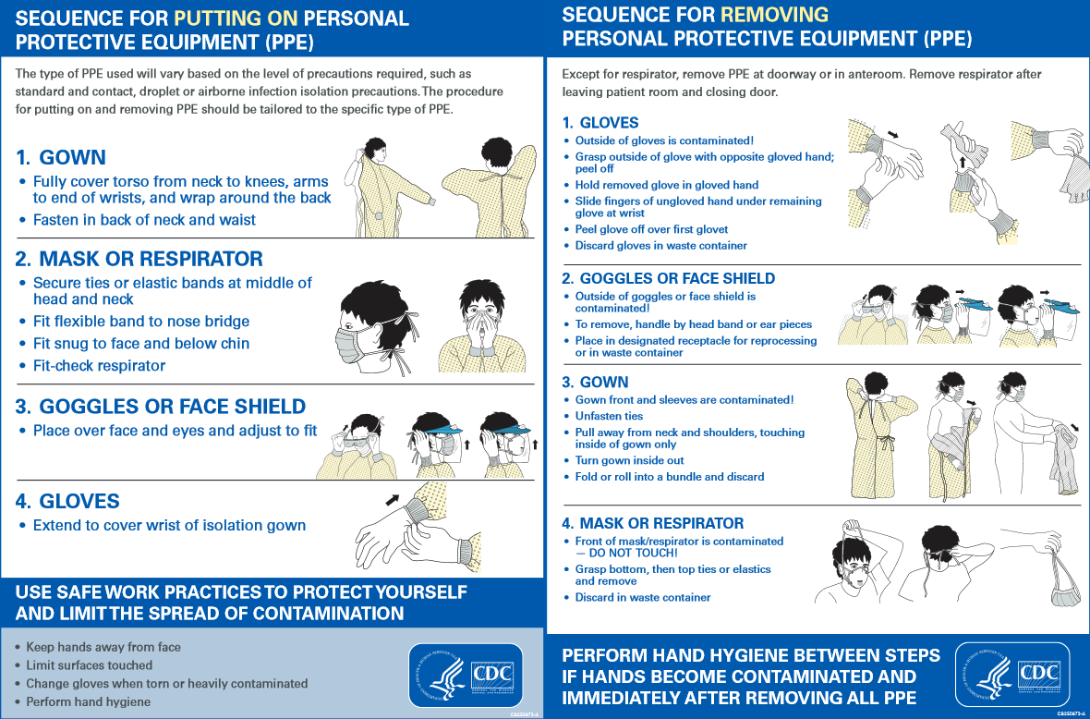
7. **Emergency Medical Dispatch (EMD):**

After discussion with the Medical Director and local Board of Health, the EMD agency should consider updating its call algorithm to reflect the current status of this ongoing pandemic. The call interrogation should currently include questions such as:

* 1. Does the patient have a fever and/or cough and/or respiratory symptoms?
  2. Has the patient been exposed to anyone who is self-quarantined for confirmed case of the novel coronavirus?
  3. Has the patient been exposed to a person with a confirmed case of the novel coronavirus or a location to which there has been a confirmed case?

1. **SCENE SAFETY FOR ANY RESPIRATORY ILLNESS:**
   1. Follow the most up to date recommended protective equipment guidelines from the CDC and the Massachusetts DPH (see 2 (a) and 2 (b) above)
   2. MINIMIZE EXPOSURE by considering the initial evaluation being performed by **ONE MEMBER** of the responding team with the highest medical training (e.g Senior Paramedic or Senior EMT)
   3. In the event of a life-threating emergency proceed with entry immediately after donning the appropriate PPE (see 2 (a) and 2 (b) above)
   4. In the evaluation of a non-critical patient:
      1. Don the appropriate PPE (see 2 (a) and 2 (b) above)
      2. Maintain a minimum distance of 6 feet from the patient and others in the home whenever possible
   5. If the patient is not in any respiratory distress, request that the patient apply a provided surgical mask over their face
   6. Ensure appropriate training in doffing appropriate PPE
   7. Ensure appropriate materials and processes in place to secure any doffed PPE
2. **TREAT THE VIRUS AS YOU WOULD ANY RESPIRATORY INFECTION**
   1. Wash your hands with soap and water for at least 20 seconds. If soap and water are not available, use an alcohol-based hand sanitizer. Ensure that between the fingers, backs of hands

<https://www.youtube.com/watch?v=IisgnbMfKvI>

* 1. Avoid touching your eyes, nose, and mouth with unwashed hands or objects.
  2. Clean and disinfect frequently touched objects and surfaces.
  3. Wash your uniforms. The virus can live on surfaces and currently it is not definitively known for how long. More is being learned about this and will be promulgated once available.

**FAQ**

1. I am running low on PPE. Where can I find more PPE?
   1. Consider contacting the following resources for assistance:
      1. Health and Medical Coordinating Coalition Sustainability
      2. Local Public Health/Board of Health
      3. Local Schools/Colleges/Universities (especially schools with allied health/healthcare programs such as EMT, nursing, physician assistant, Rad Tech, OR Tech. Medical Assistant, etcetera)
      4. Local Emergency Management
2. I have questions about COVID, who can I contact for more information?
   1. According to the Massachusetts Department of Public Health, the local public health departments can provide information helpful during this crisis
   2. Your local Affiliate Hospital Medical Director
   3. The Region 1 Western MA EMS Director, Deb Clapp
   4. The Region 1 Medical Director, Dr. Wook Beltran (540-769-7137)

Moving forward, we will be providing a weekly newsletter on this matter for the foreseeable future. We would ask if you have a question or topic you would like included in this newsletter that you please forward them to Deb Clapp at [dclapp@wmems.org](mailto:dclapp@wmems.org).

The outstanding work you do every day is crucial to our communities. Thank you for your continued efforts and support to the citizens of western Massachusetts during this event.

Very Respectfully,

Gerald (Wook) Beltran

[Wook.beltran@gmail.com](mailto:Wook.beltran@gmail.com)

(cell) 540-769-7137