This is an update concerning the COVID-19 virus. There has been a noticeable increase in virus cases nationally, and within the state of Massachusetts. The most recent information as of 11/17/2020 is included at the end of this newsletter in a table format.
As a reminder, symptoms of the virus usually occur in 2-14 days after exposure to the virus. The COVID-19 symptoms can include:
- Fever or chills
- Cough
- Shortness of breath or difficulty breathing
- Fatigue
- Muscle or body aches
- Headache
- New loss of taste or smell
- Sore throat
- Congestion or runny nose
- Nausea or vomiting
- Diarrhea

The case fatality rate has been observed to be between 0.7% to 5% (depending on which study is used) with those who are older or have underlying medical problems being at the greatest risk. Data has revealed that the severity of disease varies with about 19% who are the most ill):
- Mild disease (no or mild pneumonia) was reported in 81 percent.
- Severe disease (eg, with dyspnea, hypoxia (low oxygen levels), or >50 percent lung involvement on imaging within 24 to 48 hours) was reported in 14 percent.
- Critical disease (eg, with respiratory failure, shock, or multiorgan dysfunction) was reported in 5 percent.
- The overall case fatality rate was 2.3 percent; no deaths were reported among noncritical cases.

Below is the information sent during the last update and is repeated here as these resources are updated regularly. Region 1 felt it prudent to provide an update that your agencies may find useful.
- There is a new state website for first responders surrounding COVID-19. It has recent information on how to request PPE, quarantine guidelines, housing for First Responders who need to self-quarantine, self-care resource, as well as other resources and information this website can be found at:
https://www.frontlinema.org
- It is important that every agency develop unified contingency plans that involves all the public safety agencies (e.g. EMD, police, fire, EMS, emergency management), local public health, and local hospitals in their city/town and region.
- These plans should incorporate recommendations set forth by:
  - Local Public Health as first point of contact (who should be working with the Massachusetts Department of Public Health on providing information to their local agencies and constituency).
  - The Centers for Disease Control and Prevention (CDC)
https://www.cdc.gov/coronavirus/2019-ncov/hcp/faq.html
https://www.cdc.gov/coronavirus/2019-ncov/index.html
https://www.cdc.gov/coronavirus/2019-ncov/hcp/index.html
  - Massachusetts Department of Public Health (DPH)
https://www.mass.gov/guides/information-on-the-outbreak-of-2019-novel-coronavirus-covid-19
  - Massachusetts Office of Emergency Medical Services (OEMS)
https://www.mass.gov/orgs/office-of-emergency-medical-services
https://www.mass.gov/doc/advisory-20-10-01-covid-19-workplace-safety-standards-for-ambulance-service-locations-102320/download

- A resource for COVID-19 can also be found at
https://wmems.org/p/46/Important-COVID-19-Information

- Ensure that there is a sufficient stock of masks (e.g. surgical and N95) along with gloves and other appropriate Personal Protective Equipment (PPE) (e.g. eye protection, barrier aprons and/or suits) as there have already been identified shortages for the foreseeable future.
- Ensure that each agency has policies in place for utilization, maintenance, and storage of PPE as well as mitigation strategies. Ensure that the policies include discussion around facial hair, given that this can reduce the effectiveness of certain types of masks.
- Ensure that each agency has policies and supplies in place for cleaning and maintenance of equipment after potential exposures.
- Ensure that each agency has the appropriate training in donning and doffing of PPE. Remember, doffing is where the majority of contamination occurs, putting providers at risk!
- Ensure that each agency has the appropriate policies and training in storage and disposal of contaminated PPE as well as other equipment and supplies.
- 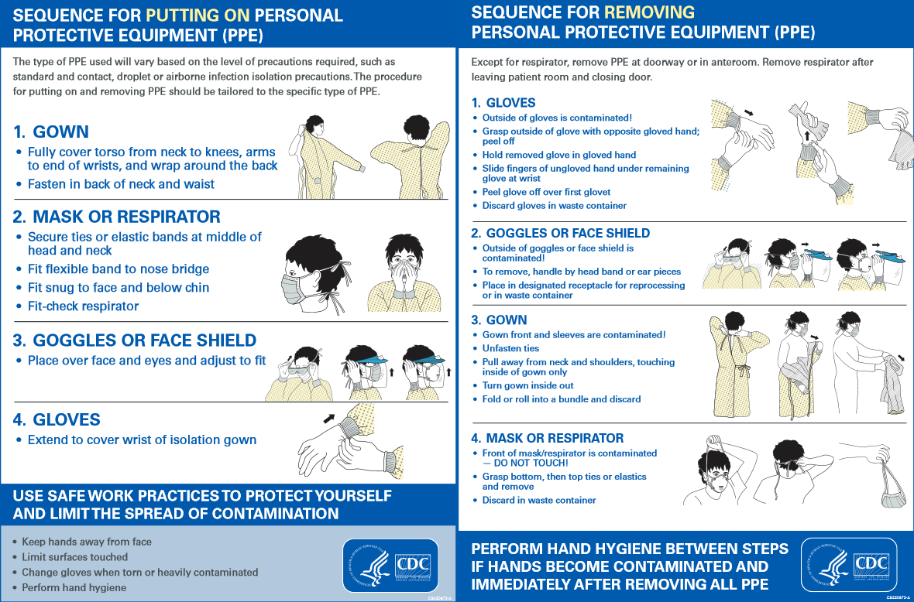

- Emergency Medical Dispatch (EMD):
After discussion with the Medical Director and local Board of Health, the EMD agency should consider updating its call algorithm to reflect the current status of this ongoing pandemic. Several services have requested all medical calls be screened with the below as well, to help protect the providers. The call interrogation should currently include questions such as:
  - Does the patient have a fever/chills and/or cough and/or respiratory symptoms?
  - Has the patient been exposed to anyone who is self-quarantined for confirmed case of the novel coronavirus?
  - Has the patient been exposed to a person with a confirmed case of the novel coronavirus or a location to which there has been a confirmed case?

- SCENE SAFETY FOR ANY RESPIRATORY ILLNESS:
  - Follow the most up to date recommended protective equipment guidelines from the CDC and the Massachusetts DPH (see (3(b)) and (3(c)) above)
  - MINIMIZE EXPOSURE by considering the initial evaluation being performed by ONE MEMBER of the responding team with the highest medical training (e.g Senior Paramedic or Senior EMT)
  - In the event of a life-threating emergency proceed with entry immediately after donning the appropriate PPE (see (3(b)) and (3(c)) and (8) above)
  - In the evaluation of a non-critical patient:
    - Don the appropriate PPE (see (3(a)) and (3(b)) above)
    - Maintain a minimum distance of 6 feet from the patient and others in the home whenever possible
  - Request that the patient apply a provided surgical mask over their face
  - If the patient has been exposed to COVID-19 and needs an airway, consider the supraglottic airway as endotracheal intubation is an aerosolizing procedure putting the medical providers and bystanders at risk for exposure to the disease (see Statewide Treatment Protocol 1.2(d) ). See FAQ (9)
  - When at the hospital ensure safety of the hospital and EMS personnel by avoiding touching anything while in PPE, also avoid leaning on counters while in PPE. Paperwork and/or personal items from a patient's home or room at facility should be treated as contaminated and not put on counters where healthcare care providers work or should be left in the room, whatever practice minimizes other provider and family member exposure.
  - Ensure appropriate training in doffing appropriate PPE. Doffing is often the most challenging part of PPE to avoid contamination.
  - Ensure appropriate materials and processes in place to secure any doffed PPE

- TREAT THE VIRUS AS YOU WOULD ANY RESPIRATORY INFECTION
  - Wash your hands with soap and water for at least 20 seconds. If soap and water are not available, use an alcohol-based hand sanitizer. Ensure that between the fingers, backs of hands are washed.
https://www.youtube.com/watch?v=IisgnbMfKvI
  - Avoid touching your eyes, nose, and mouth with unwashed hands or objects.
  - Clean and disinfect frequently touched objects and surfaces.
  - Wash your uniforms. The virus can remain viable on surfaces for some time. More is being learned about this and will be promulgated once available.
FAQ
- Where can I get tested for COVID?
  - The state of Massachusetts has URL with the testing sites:
https://www.mass.gov/covid-19-testing
Click on the button that says, “Find a site near you” and list of testing sites will be shown on a map.
  - There is local testing being done through the state locally. The sign up can be found at: https://docs.google.com/forms/d/e/1FAIpQLSeBSyAREAdQl5WT02PvZeiK6tlw0h1XqEUUk3NMwmbyXSJSNg/viewform or using a QRV code

- Where can the order for mandated mask usage be found?
COVID-19 Order No. 55
https://www.mass.gov/doc/covid-19-order-55/download
This order appears to apply to all public safety agencies (i.e. police, fire, EMS, EMD, etc).

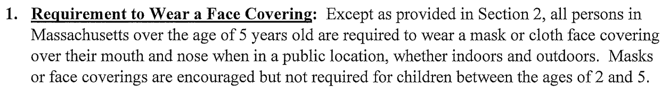

- Do I have to wear a mask while at my workplace?
See Order No. 55 above (FAQ#2)
https://www.mass.gov/doc/advisory-20-10-01-covid-19-workplace-safety-standards-for-ambulance-service-locations-102320/download

OEMS has required all ambulance services comply with the following:
- All persons, including employees, customers, and vendors should remain at least six feet apart to the greatest extent possible, both inside and outside workplaces.
• Establish protocols to ensure that employees can practice adequate social distancing.
• Provide signage for safe social distancing.
• Require face coverings or masks for all employees.
• Provide hand washing capabilities throughout the workplace.
• Ensure frequent hand washing by employees and adequate supplies to do so. If hand washing is not readily accessible, then provide access to alcohol-based hand rub that is at least 60% alcohol.
• Provide regular sanitization of high touch areas, such as workstations, equipment, screens, doorknobs, restrooms throughout work site.
• Provide training for employees regarding the social distancing and hygiene protocols.
• Ensure that employees who are displaying COVID-19-like symptoms do not report to work.
• Establish a plan for employees developing COVID-19 symptoms at work, and a returnto-work plan.
• Employers should take measures to ensure employees comply with all State-issued rules concerning out of state travel for any employer-paid or -reimbursed travel.
• Establish and maintain cleaning protocols specific to an ambulance service location.
• When an employee is diagnosed with COVID-19 and has been at work within 48 hours of diagnosis or symptoms, cleaning and disinfecting must be performed at the workplace.
• Disinfection of all common surfaces must take place at intervals appropriate to an ambulance service location.

- What PPE is appropriate with a suspected COVID patient? The Massachusetts statewide treatment protocols for EMS (1.2) states:
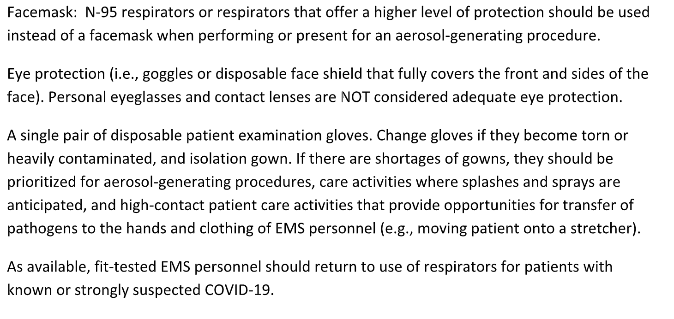
- I am running low on PPE. Where can I find more PPE?
  - Consider contacting the following resources for assistance:
    - Massachusetts has a website helping with this dynamic process.
https://www.mass.gov/info-details/personal-protective-equipment-ppe-during-covid-19

      - Currently, medical facilities, community health centers, private/non-fire based EMS, local public health submit their requests to the Health and Medical Coordinating Coalition Sustainability (HMCC). For Region 1 their website is at:
https://region1hmcc.org/

Regional HMCC contact info can be found here and below:
HMCC Region 1 Franklin Regional Council of Governments (413-773-1502)
HMCC Region 2 City of Worcester (508-408-5173)
HMCC Region 3 Metropolitan Area Planning Council (978-946-8130)
HMCC Region 4ab Cambridge Health Alliance (857-239-0662)
HMCC Region 4c Boston Public Health Commission (617-343-6920)

      - If you are a local Police Department, Fire Department, joint Fire/EMS Department, county agencies (ex. Sheriff), state agency, or local municipality:
Go to this link to access the MEMA WebEOC make a request
    - Local Public Health/Board of Health
    - Local Schools/Colleges/Universities (especially schools with allied health/healthcare programs such as EMT, nursing, physician assistant, Rad Tech, OR Tech. Medical Assistant, etcetera)
    - Local Emergency Management

- I have questions about COVID, who can I contact for more information?
  - According to the Massachusetts Department of Public Health, the local public health departments can provide information helpful during this crisis
  - Your local Affiliate Hospital Medical Director
  - The Region 1 Western MA EMS Director, Deb Clapp
  - The Region 1 Medical Director, Dr. Wook Beltran (540-769-7137)
  - The state COVID hotline 2-1-1

- What are the most recent COVID statistics?
https://www.mass.gov/info-details/covid-19-response-reporting

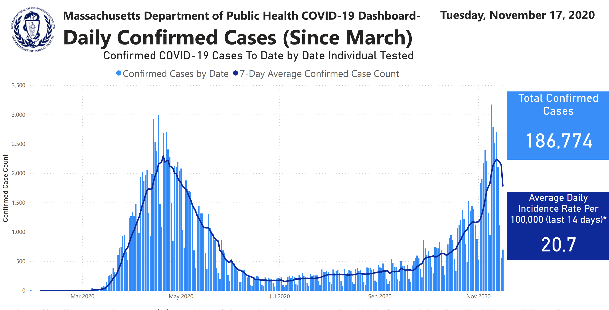
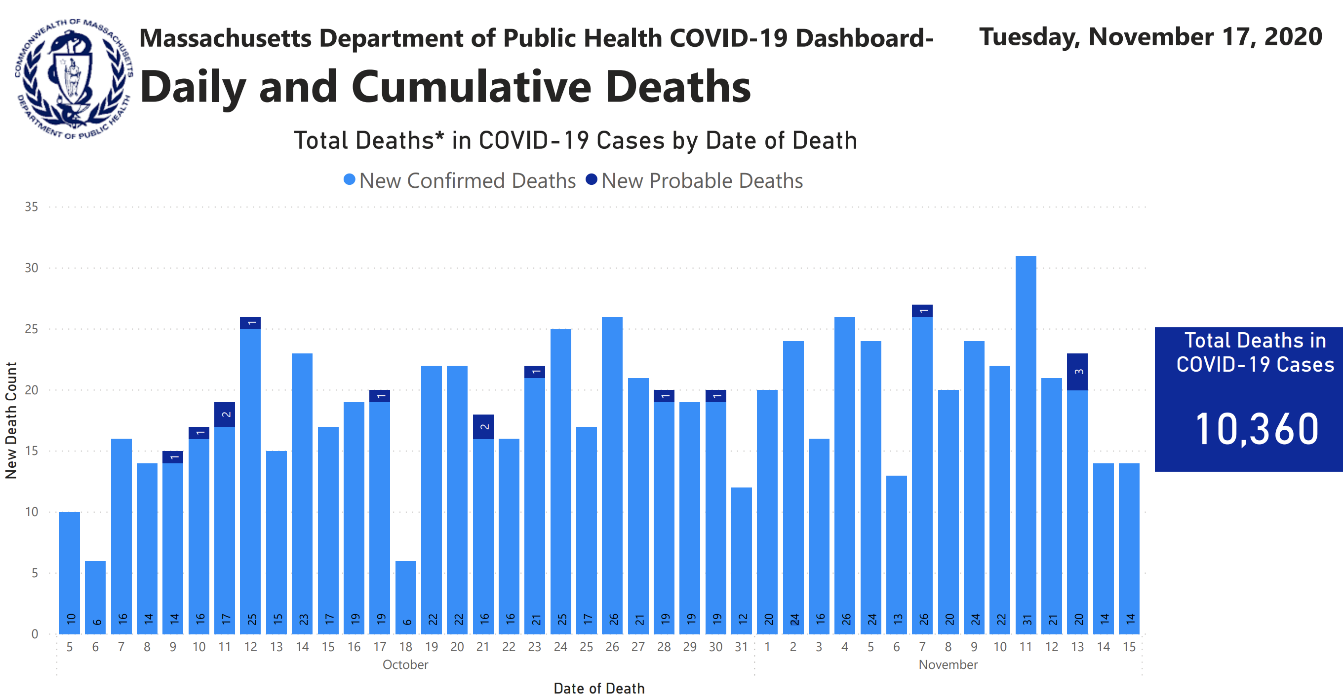
- If I have had COVID, when can I return to work?

This is determined by your department/agency policy. The CDC guidelines are listed below and the URL is found at: https://www.cdc.gov/coronavirus/2019-ncov/hcp/return-to-work.html

This is for healthcare providers (HCP)
- Symptom-based strategy for determining when HCP can return to work.
HCP with mild to moderate illness who are not severely immunocompromised:
- At least 10 days have passed since symptoms first appeared and
- At least 24 hours have passed since last fever without the use of fever-reducing medications and
- Symptoms (e.g., cough, shortness of breath) have improved
Note: HCP who are not severely immunocompromised and were asymptomatic throughout their infection may return to work when at least 10 days have passed since the date of their first positive viral diagnostic test.
HCP with severe to critical illness or who are severely immunocompromised¹:
- At least 10 days and up to 20 days have passed since symptoms first appeared
- At least 24 hours have passed since last fever without the use of fever-reducing medications and
- Symptoms (e.g., cough, shortness of breath) have improved
- Consider consultation with infection control experts
Note: HCP who are severely immunocompromised but who were asymptomatic throughout their infection may return to work when at least 10 days and up to 20 days have passed since the date of their first positive viral diagnostic test.
As described in the Decision Memo, an estimated 95% of severely or critically ill patients, including some with severe immunocompromise, no longer had replication-competent virus 15 days after onset of symptoms; no patient had replication-competent virus more than 20 days after onset of symptoms. The exact criteria that determine which HCP will shed replication-competent virus for longer periods are not known. Disease severity factors and the presence of immunocompromising conditions should be considered in determining the appropriate duration for specific HCP. For example, HCP with characteristics of severe illness may be most appropriately managed with at least 15 days before return to work.
- Test-Based Strategy for Determining when HCP Can Return to Work.
In some instances, a test-based strategy could be considered to allow HCP to return to work earlier than if the symptom-based strategy were used. However, as described in the Decision Memo, many individuals will have prolonged viral shedding, limiting the utility of this approach. A test-based strategy could also be considered for some HCP (e.g., those who are severely immunocompromised¹) in consultation with local infectious diseases experts if concerns exist for the HCP being infectious for more than 20 days.
The criteria for the test-based strategy are:
HCP who are symptomatic:
- Resolution of fever without the use of fever-reducing medications and
- Improvement in symptoms (e.g., cough, shortness of breath), and
- Results are negative from at least two consecutive respiratory specimens collected ≥24 hours apart (total of two negative specimens) tested using an FDA-authorized molecular viral assay to detect SARS-CoV-2 RNA. See Interim Guidelines for Collecting, Handling, and Testing Clinical Specimens for 2019 Novel Coronavirus (2019-nCoV).
HCP who are not symptomatic:
- Results are negative from at least two consecutive respiratory specimens collected ≥24 hours apart (total of two negative specimens) tested using an FDA-authorized molecular viral assay to detect SARS-CoV-2 RNA. See Interim Guidelines for Collecting, Handling, and Testing Clinical Specimens for 2019 Novel Coronavirus (2019-nCoV).

- Is endotracheal intubation problematic with a patient who might have COVID?
  - This is considered a procedure with a high risk of aerosolization, and if another modality can be utilized which is lower risk, consider using it (e.g. supraglottic airways).
  - In fact, state treatment protocol 1.2 states:
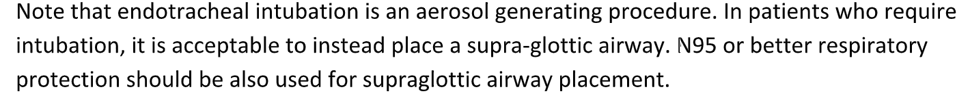

As long as there is interest, we will continue to provide this weekly newsletter on this matter for the foreseeable future. We would ask if you have a question or topic you would like included in this newsletter that you please forward them to Deb Clapp at dclapp@wmems.org.

The outstanding work you do every day is crucial to our communities. Thank you for your continued efforts and support to the citizens of western Massachusetts during this event.

Very Respectfully,

Gerald (Wook) Beltran
Wook.beltran@gmail.com
(cell) 540-769-7137

