This is a weekly update concerning the novel Corona virus. The virus continues to spread. The most recent information as of 03/29/2020 is included at the end of this newsletter in a table format.
As a reminder, the novel Corona virus like many other viral syndromes with symptoms such as:
- Fever
- Cough
- Shortness of breath
- Fatigue
- Decreased appetite

The incubation period for the disease is 14 days with a case fatality rate between 0.7% to 5% with those who are older or have underlying medical problems being at greatest risk,. Data from other countries has revealed that the severity of disease varies:
- Mild - 80% of patients will have symptoms of a viral illness or mild pneumonia
- Severe - 15% of patients will have severe symptoms (e.g. shortness of breath, hypoxia, etc.)
- Critical – 5% of patients be critical (e.g. respiratory failure, shock, multiorgan dysfunction)

Below is the information sent during the last update and is repeated here as these resources are updated regularly. Region 1 felt it prudent to provide an update that your agencies may find useful.
- It is important that every agency develop unified contingency plans that involves all the public safety agencies (e.g. EMD, police, fire, EMS, emergency management), local public health, and local hospitals in their city/town and region.
- These plans should incorporate recommendations set forth by:
  - Local Public Health as first point of contact (who should be working with the Massachusetts Department of Public Health on providing information to their local agencies and constituency).
  - The Centers for Disease Control and Prevention (CDC)
https://www.cdc.gov/coronavirus/2019-ncov/hcp/faq.html
https://www.cdc.gov/coronavirus/2019-ncov/index.html
https://www.cdc.gov/coronavirus/2019-ncov/hcp/index.html
  - Massachusetts Department of Public Health (DPH)
https://www.mass.gov/guides/information-on-the-outbreak-of-2019-novel-coronavirus-covid-19
https://www.mass.gov/clinical-advisory/update-and-interim-guidance-on-outbreak-of-2019-novel-coronavirus-2019-ncov-in
  - Massachusetts Office of Emergency Medical Services (OEMS)
https://www.mass.gov/orgs/office-of-emergency-medical-services

- A resource for COVID-19 can also be found at
https://wmems.org/p/46/Important-COVID-19-Information

- Ensure that there is a sufficient stock of masks (e.g. surgical and N95) along with gloves and other appropriate Personal Protective Equipment (PPE) (e.g. eye protection, barrier aprons and/or suits) as there have already been identified shortages for the foreseeable future.
- Ensure that each agency has policies in place for utilization, maintenance, and storage of PPE as well as mitigation strategies. Ensure that the policies include discussion around facial hair, given that this can reduce the effectiveness of certain types of masks.
- Ensure that each agency has policies and supplies in place for cleaning and maintenance of equipment after potential exposures.
- Ensure that each agency has the appropriate training in donning and doffing of PPE.
- Ensure that each agency has the appropriate policies and training in storage and disposal of contaminated PPE as well as other equipment and supplies.
- 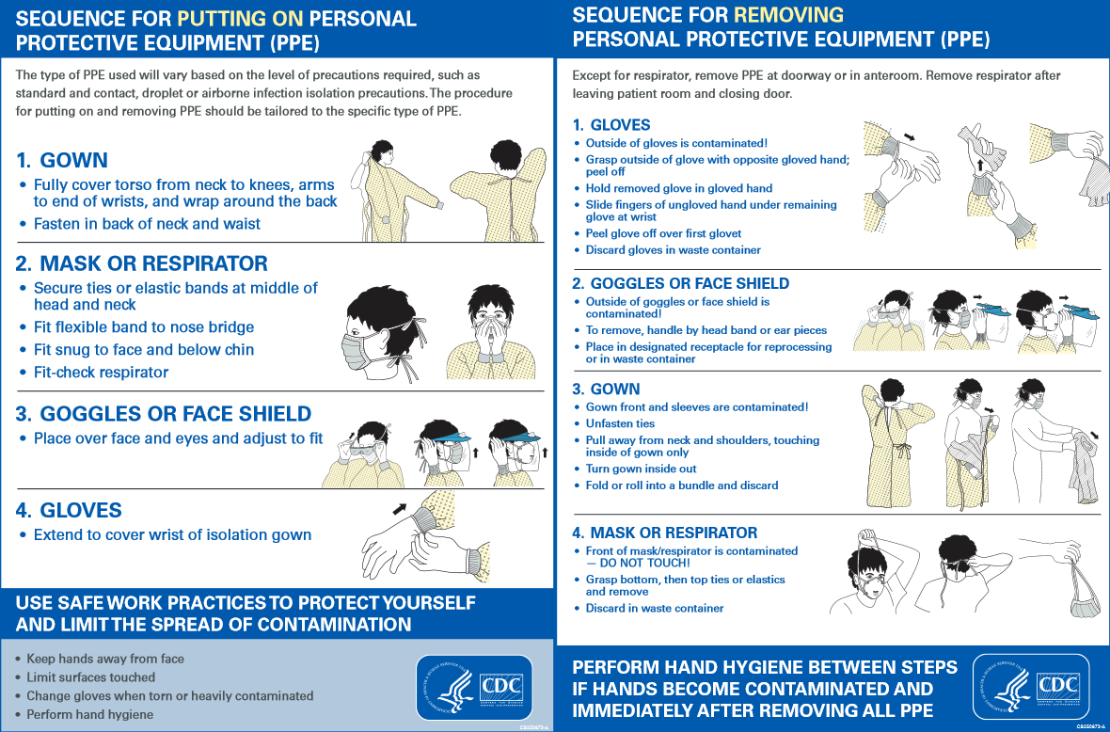

- Emergency Medical Dispatch (EMD):
After discussion with the Medical Director and local Board of Health, the EMD agency should consider updating its call algorithm to reflect the current status of this ongoing pandemic. Several services have requested all medical calls be screened with the below as well, to help protect the providers. The call interrogation should currently include questions such as:
  - Does the patient have a fever/chills and/or cough and/or respiratory symptoms?
  - Has the patient been exposed to anyone who is self-quarantined for confirmed case of the novel coronavirus?
  - Has the patient been exposed to a person with a confirmed case of the novel coronavirus or a location to which there has been a confirmed case?

- SCENE SAFETY FOR ANY RESPIRATORY ILLNESS:
  - Follow the most up to date recommended protective equipment guidelines from the CDC and the Massachusetts DPH (see (2(b)) and (2(c)) above)
  - MINIMIZE EXPOSURE by considering the initial evaluation being performed by ONE MEMBER of the responding team with the highest medical training (e.g Senior Paramedic or Senior EMT)
  - In the event of a life-threating emergency proceed with entry immediately after donning the appropriate PPE (see (2(b)) and (2(c)) and (8) above)
  - In the evaluation of a non-critical patient:
    - Don the appropriate PPE (see (2(a)) and (2(b)) above)
    - Maintain a minimum distance of 6 feet from the patient and others in the home whenever possible
  - If the patient is not in any respiratory distress, request that the patient apply a provided surgical mask over their face
  - If the patient has been exposed to COVID-19 and needs an airway, consider the supraglottic airway as endotracheal intubation is an aerosolizing procedure putting the medical providers and bystanders at risk for exposure to the disease (see Statewide Treatment Protocol 1.2(d) ). See FAQ (8)
  - When at the hospital ensure safety of the hospital and EMS personnel by avoiding touching anything while in PPE, also avoid leaning on counters while in PPE. Paperwork and/or personal items from a patient's home or room at facility should be treated as contaminated and not put on counters where healthcare care providers work or should be left in the room, whatever practice minimizes other provider and family member exposure.
  - Ensure appropriate training in doffing appropriate PPE. Doffing is often the most challenging part of PPE to avoid contamination.
  - Ensure appropriate materials and processes in place to secure any doffed PPE

- TREAT THE VIRUS AS YOU WOULD ANY RESPIRATORY INFECTION
  - Wash your hands with soap and water for at least 20 seconds. If soap and water are not available, use an alcohol-based hand sanitizer. Ensure that between the fingers, backs of hands are washed.
https://www.youtube.com/watch?v=IisgnbMfKvI
  - Avoid touching your eyes, nose, and mouth with unwashed hands or objects.
  - Clean and disinfect frequently touched objects and surfaces.
  - Wash your uniforms. The virus can live on surfaces and currently it is not definitively known for how long. More is being learned about this and will be promulgated once available.
FAQ
- I am running low on PPE. Where can I find more PPE?
  - Consider contacting the following resources for assistance:
    - Massachusetts has a website helping with this dynamic process.
https://www.mass.gov/info-details/covid-19-guidance-and-directives#guidance-on-prioritization-of-ppe-in-ma-

      - Currently, medical facilities, community health centers, private/non-fire based EMS, local public health submit their requests to the Health and Medical Coordinating Coalition Sustainability (HMCC). For Region 1 their website is at:
https://region1hmcc.org/

Regional HMCC contact info can be found here and below:
HMCC Region 1 Franklin Regional Council of Governments (413-773-1502)
HMCC Region 2 City of Worcester (508-408-5173)
HMCC Region 3 Metropolitan Area Planning Council (978-946-8130)
HMCC Region 4ab Cambridge Health Alliance (857-239-0662)
HMCC Region 4c Boston Public Health Commission (617-343-6920)

      - If you are a local Police Department, Fire Department, joint Fire/EMS Department, county agencies (ex. Sheriff), state agency, or local municipality:
Go to this link to access the MEMA WebEOC make a request
    - Local Public Health/Board of Health
    - Local Schools/Colleges/Universities (especially schools with allied health/healthcare programs such as EMT, nursing, physician assistant, Rad Tech, OR Tech. Medical Assistant, etcetera)
    - Local Emergency Management

- I have questions about COVID, who can I contact for more information?
  - According to the Massachusetts Department of Public Health, the local public health departments can provide information helpful during this crisis
  - Your local Affiliate Hospital Medical Director
  - The Region 1 Western MA EMS Director, Deb Clapp
  - The Region 1 Medical Director, Dr. Wook Beltran (540-769-7137)
  - The state COVID hotline 2-1-1

- What are the most recent COVID statistics?
  - 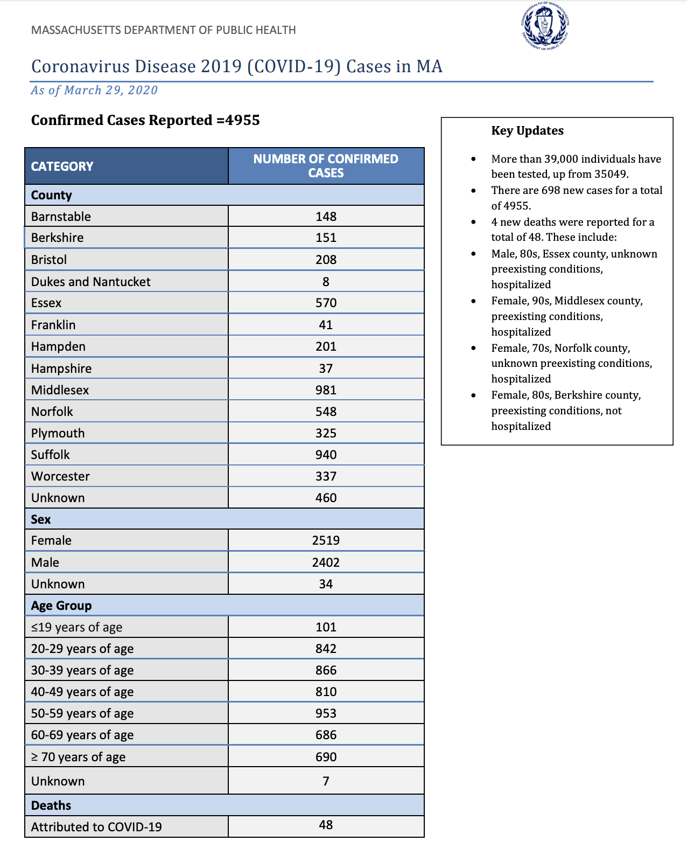

- What are the latest recommendations about isolating or quarantining?
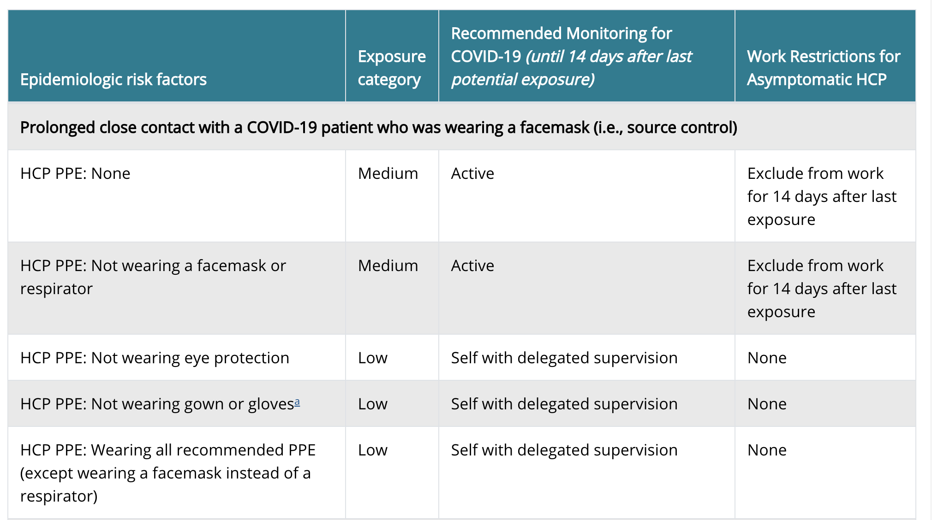
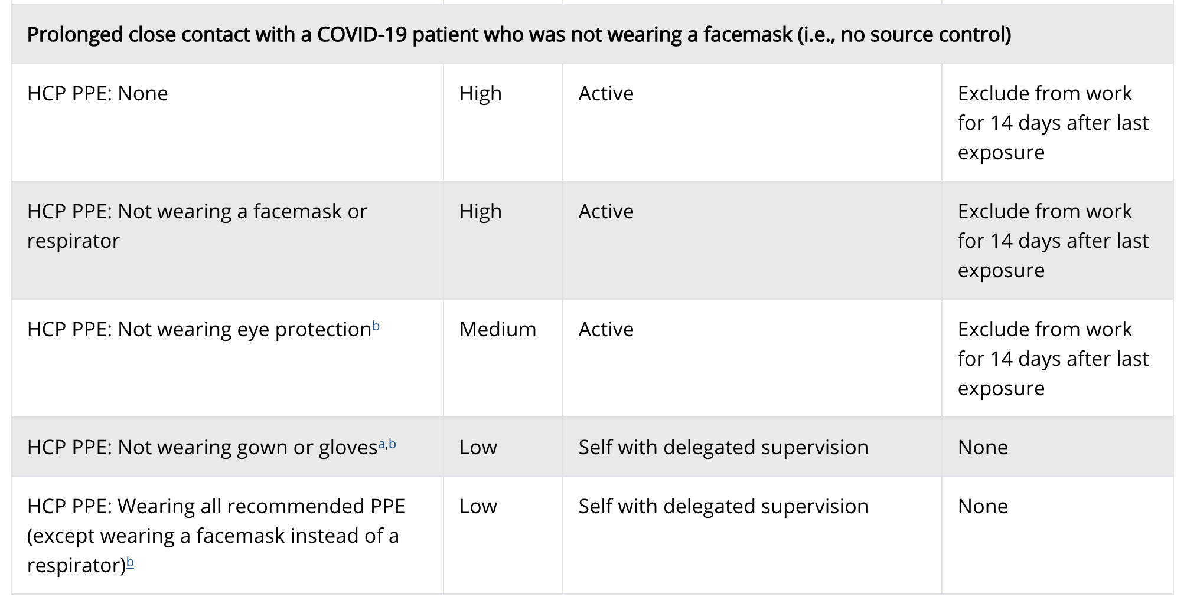

- If I have had COVID, when can I return to work?

This is determined by your department/agency policy.

The CDC website (https://www.cdc.gov/coronavirus/2019-ncov/healthcare-facilities/hcp-return-work.html) makes the following recommendations:
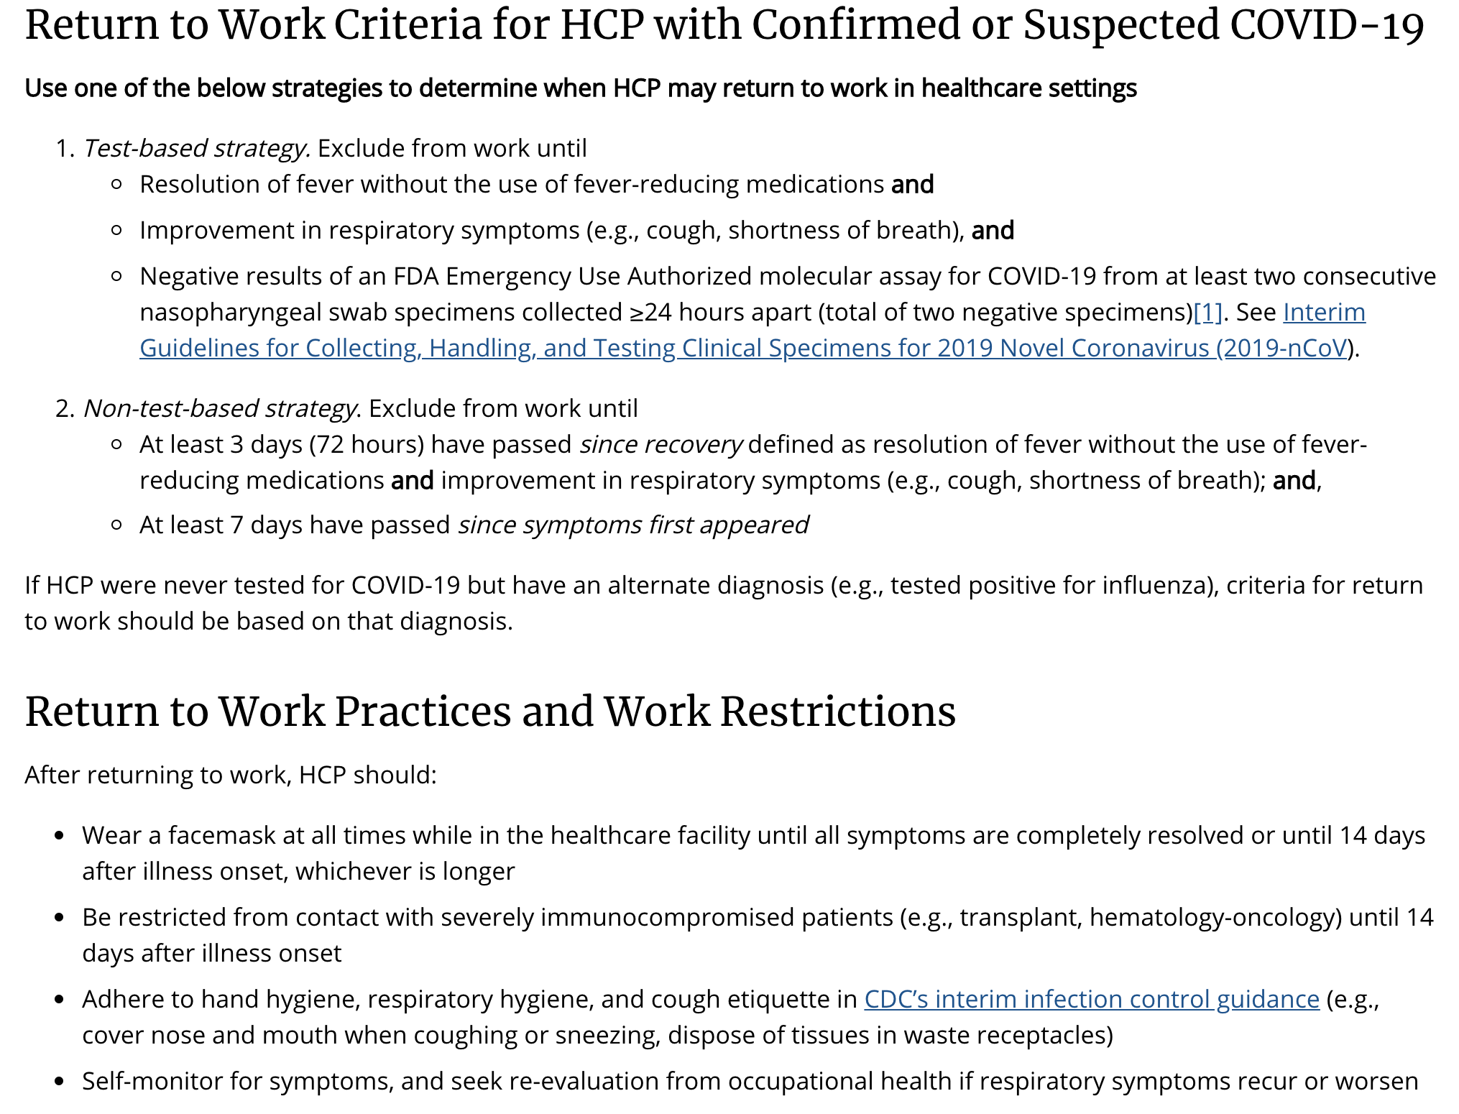

- When will first responder COVID testing be available?
  - The Department of Public in Massachusetts has information on its website that references the CDC website:
https://www.cdc.gov/coronavirus/2019-ncov/symptoms-testing/testing.html
- 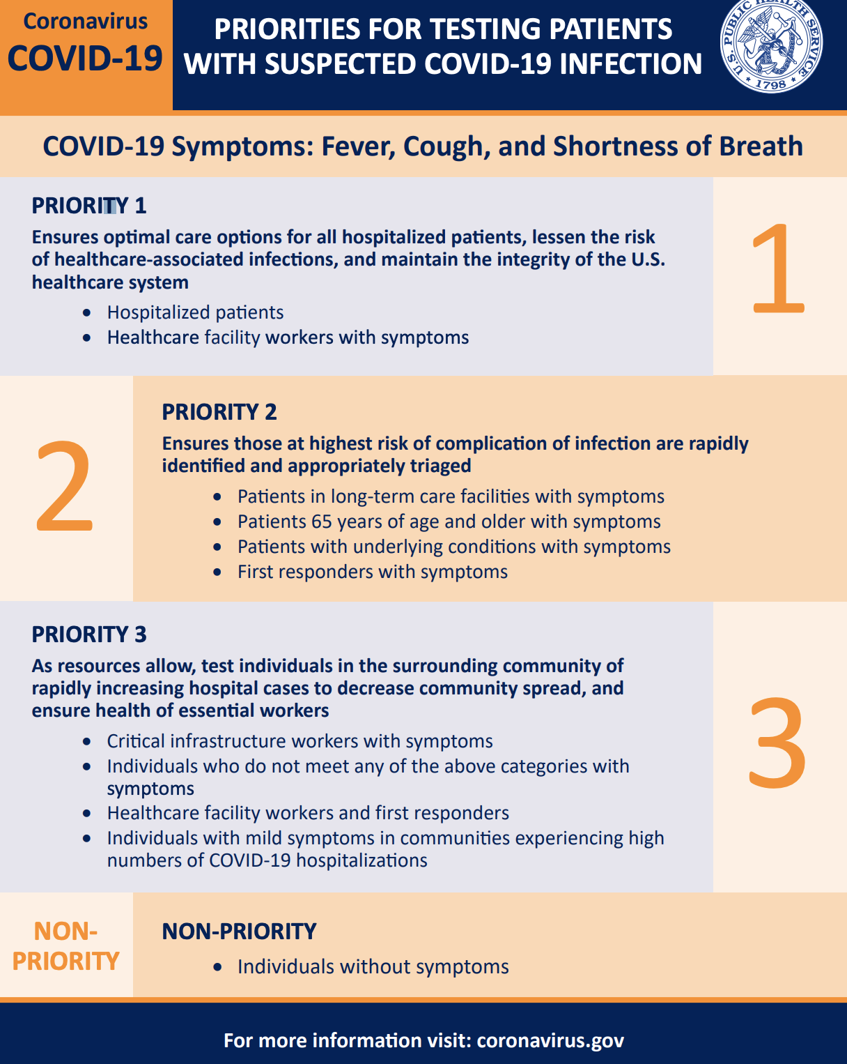
  - 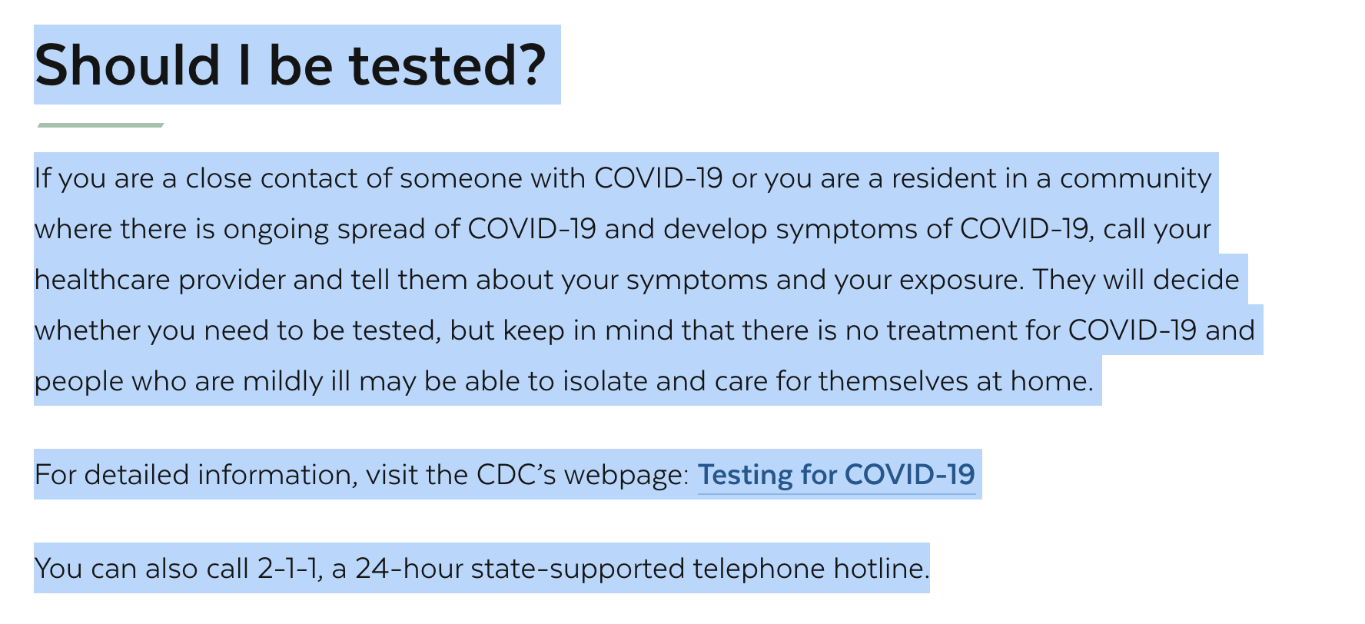
  - One of the challenges with getting testing is there are limited reagents and labs doing the testing. This will likely change over the next weeks and months, but currently it is challenging. Local hospitals are receiving more availability of reagents and various labs are similarly increasing the capacity to test. In the near future, testing will likely become more accessible to public safety and hospital employees.
  - Recently, CVS piloted a site in Shrewsbury for testing first responders. An article appeared in the press about this (this appears to be testing by a private entity):
https://www.wbur.org/commonhealth/2020/03/19/massachusetts-cvs-drive-thru-covid-19-coronavirus
  - Massachusetts is maintaining a list of testing sites for COVID which are available to the public, but require an appointment and some of these will only test those with symptoms (due to limited reagents and labs…see 7(b) FAQ above). This list of testing sites can be found at:
https://www.mass.gov/doc/ma-covid-19-testing-sites/download

- Is endotracheal intubation problematic with a patient who might have COVID?
  - This is considered a procedure with a high risk of aerosolization, and if another modality can be utilized which is lower risk, consider using it (e.g. supraglottic airways).
  - In fact, state treatment protocol 1.2 references this:
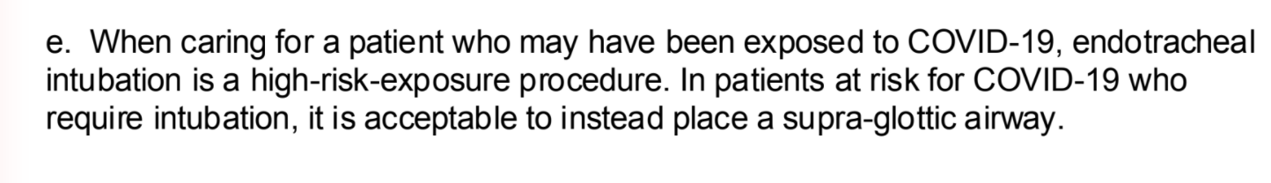
- How do I dispose of PPE or linen with a COVID patient?
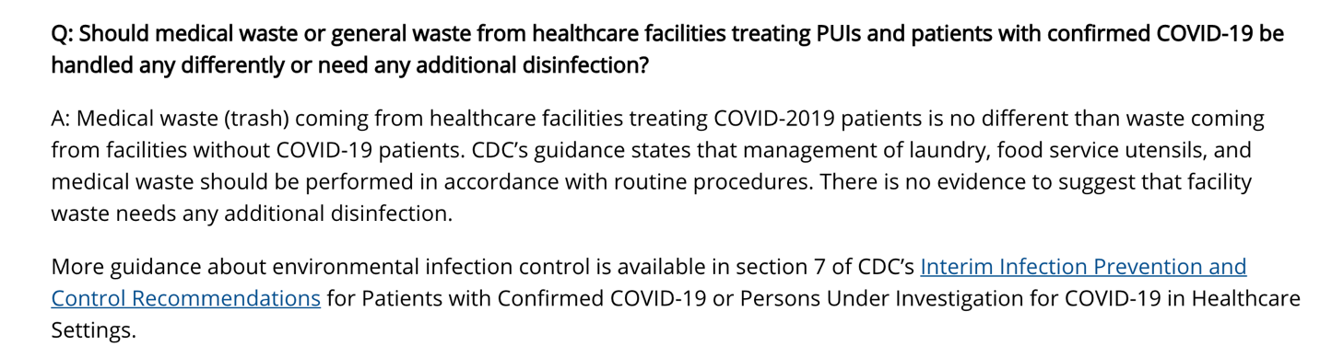
- What body fluids is at risk for COVID transmission?
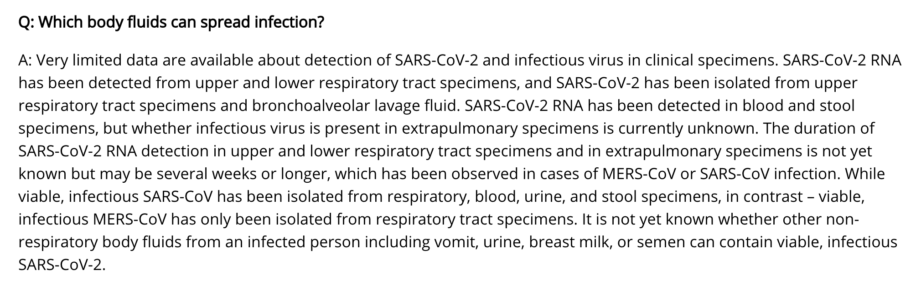

As long as there is interest, we will continue to provide this weekly newsletter on this matter for the foreseeable future. We would ask if you have a question or topic you would like included in this newsletter that you please forward them to Deb Clapp at dclapp@wmems.org.

The outstanding work you do every day is crucial to our communities. Thank you for your continued efforts and support to the citizens of western Massachusetts during this event.

Very Respectfully,

Gerald (Wook) Beltran
Wook.beltran@gmail.com
(cell) 540-769-7137

